**4th order Runge-Kutta method and Orbits**

**Computing exercise 4**

By khalil Pierre

The aims of this investigation were to use the 4th order Runge Kutta method to numerically solve the equation of motion of a rocket, moving in a gravitational potential well.

**Background**

The 4th order Runge-Kutta method can be used to numerically solve ordinary differential equations (ODEs) of the form

$$\begin{aligned}\frac{dx}{dt}=f\left(x,t\right) , \#\left(1\right)\end{aligned}$$

If the initial conditions (specifically x(t0) = x0 ) are known. In equation 1 the value of x is determined by the unknown solution to the differential equation. The solution is a function of t (time). X can be either a scalar or vector quantity. The 4th order Runge-Kutta method uses the value of the solution, xn at some point tn to approximate the value of the solution at tn+1 where

$$\begin{aligned}t_{n+1}=t_{n}+∆t ,\#\left(2\right)\end{aligned}$$

Δt is the time step. To approximate the value of xn+1 the values of the Runge-Kutta coefficients must be calculated. The Runge-Kutta coefficients are calculated using the following equations

$$\begin{aligned}k_{1}=f\left(t_{n},x_{n}\right) , \#\left(3\right)\end{aligned}$$

$$\begin{aligned}k_{2}=f\left(t_{n}+\frac{∆t}{2}, x_{n}+\frac{∆t}{2}k_{1}\right) , \#\left(4\right)\end{aligned}$$

$$\begin{aligned} k_{3}=f\left(t_{n}+\frac{∆t}{2},x_{n}+\frac{∆t}{2}k_{2}\right), \#\left(5\right)\end{aligned}$$

$$\begin{aligned}k_{4}=f\left(t_{n}+∆t,{ x}_{n}+∆tk_{3}\right). \#\left(6\right)\end{aligned}$$

Each coefficient uses equation 1 to estimate the gradient of the solution at different points between tn and tn+1. K1 calculates the gradient of the solution at the beginning of the interval, k2 uses k1 to estimate the gradient at the midpoint of the interval, k3 uses k2 to again estimate the gradient at the midpoint and finally k4 estimates the gradient of the slope at the end of the interval. Multiplying each of these coefficients (gradients) by the time step Δt gives an approximate value for the change in x

$$\begin{aligned}\frac{dx}{dt}∆t≈∆x.\#\left(7\right)\end{aligned}$$

The weighted average of Δx predicted by each of the coefficients is then used to calculate xn+1. Greater weight is given to the Δx predicted by the coefficients at the midpoints then at the endpoints. Xn+1 is therefor given by

$$\begin{aligned}x_{n+1}=x_{n}+\frac{∆t}{6}\left(k_{1}+{2k}_{2}+{2k}_{3}+k_{4}\right). \#\left(8\right)\end{aligned}$$

The size of the interval Δt determines the accuracy of the numerical method with the numerical solution becoming exact as Δt goes to zero.

**Part A): Earth rocket system**

The task for part A was to create a program in python which used the 4th order Runge-Kutta method to numerically solve the equation of motion of a rocket moving within the earths gravitational potential well. For simplicity the position of the earth was treated as being constant and placed at the origin of the coordinate system. The equation of motion of a rocket in earths potential well is then

$$\begin{aligned}m\ddot{r}=\frac{mMG}{{\left|r\right|}^{2}}\hat{r}=\frac{mMG}{{\left|r\right|}^{3}}r, \#\left(9\right)\end{aligned}$$

where $r$ is the position vector of the rocket, m is the mass of the rocket, M is the mass of the earth G is the gravitational constant and $\ddot{r}$ is the acceleration of the rocket. Equation 4 is a second order ODE, to use the 4th order Runge-Kutta method equation 9 needs to be split into 2 first order ODEs. Equation 9 then becomes

$$\begin{aligned}\frac{dv}{dt}=f_{1}\left(t,r,v\right)=-\frac{MG}{{\left|r\right|}^{3}}r, \#\left(10\right), \end{aligned}$$

$$\begin{aligned}\frac{dr}{dt}=f_{2}\left(t,r,v\right)=v,\#\left(11\right)\end{aligned}$$

where ***v*** is the velocity of the rocket. The Runge-Kutta method then be must be applied simultaneously to equation 10 and 11 to find the position and velocity solutions. To apply the method simultaneously the Runge-Kutta coefficients must be split into two sets of coefficients, one set for equation 10 and one for equation 11. To calculate each subsequent coefficient in both sets the previous coefficients must be calculated for both sets as the solution to equation 11 depends on velocity and the solution to equation 10 depends on position. The coefficients become

$$\begin{aligned}k_{1,r}=f_{2}\left(t,r,v\right)=v_{n} , \#\left(12\right)\end{aligned}$$

$$\begin{aligned}k_{1,v}=f_{1}\left(t,r,v\right)= -\frac{MG}{{\left|r_{n}\right|}^{3}}r_{n} , \#\left(13\right)\end{aligned}$$

$$\begin{aligned}k_{2,r}=f_{2}\left(t+\frac{∆t}{2},r+\frac{∆t}{2}k_{1,r} ,v+\frac{∆t}{2}k_{1,v}\right)=v_{n}+\frac{∆t}{2}k_{1,v} ,\#\left(14\right)\end{aligned}$$

$$\begin{aligned}k_{1,v}=f_{1}\left(t+\frac{∆t}{2},r+\frac{∆t}{2}k_{1,r} ,v+\frac{∆t}{2}k_{1,v}\right)= -\frac{MG}{{\left|r_{n}+\frac{∆t}{2}k_{1,r}\right|}^{3}}\left(r_{n}+\frac{∆t}{2}k_{1,r}\right)…\#\left(15\right)\end{aligned}$$

The Runge-Kutta coefficients are vectors here as position and velocity are vectors. The position and velocity values are therefor given by

$$\begin{aligned}r_{n+1}=r_{n}+\frac{∆t}{6}\left(k_{1,r}+{2k}_{2,r}+{2k}_{3,r}+k_{4,r}\right), \#\left(16\right)\end{aligned}$$

$$\begin{aligned}v_{n+1}=v_{n}+\frac{∆t}{6}\left(k_{1,v}+{2k}_{2,v}+{2k}_{3,v}+k_{4,v}\right). \#\left(17\right)\end{aligned}$$

A while loop was used in conjunction with equation 16 and 17 to generate plots of the rockets motion.

An object moving through earths gravitational potential well with a velocity less than the escape velocity (minimum velocity required for an object to escape the gravitational attraction of an object), will either orbit the earth or crash into it. The numerical solution to equation 9 should be able to simulate the orbits of a gravitationally bound object. A gravitationally bound object will move in a circular orbit if it has no radial velocity and its tangential velocity meets the following condition

$$\begin{aligned}v_{circ}=\sqrt{\frac{GM}{\left|r\right|}}.\#\left(18\right)\end{aligned}$$

If the object has a tangential velocity less than or greater then vcirc it will orbit the earth in an eccentric orbit provided its velocity is still less than the escape velocity and the object doesn’t crash into the earth. To simulate both the eccentric and circular orbits of a gravitationally bound rocket a while loop was used to plot the motion of a rocket with an initial radial position of twice the earths radius and a range of initial tangential velocities including the tangential velocity of a circular orbit (radial velocity was taken to be 0). The following plot was obtained:

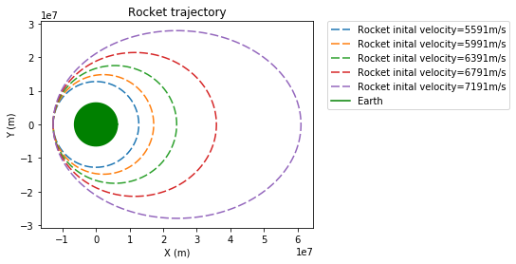

Figure 1 plot of rocket trajectories from an initial position of (-12742,0) Km where the initial tangential velocity is given in the key.

The rocket with an initial tangential velocity of 5591 m/s moves in a circular orbit as predicted by equation 18.

As there are no external forces acting on the system the total energy should be conserved. The total energy is given by

$$\begin{aligned}E=\frac{1}{2}mv^{2}-\frac{GMm}{r} , \#\left(19\right)\end{aligned}$$

where the 1st term is the kinetic energy of the rocket and the second term is the gravitational potential energy of the rocket. Plotting the potential, kinetic and total energy of an elliptical orbit against time results in the following plot:

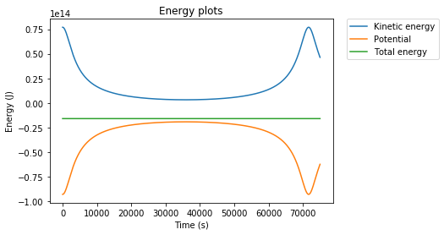

Figure 2 Energy plot of rocket with an initial starting position of (-12742,0) Km and an initial tangential velocity of 7191 m/s.

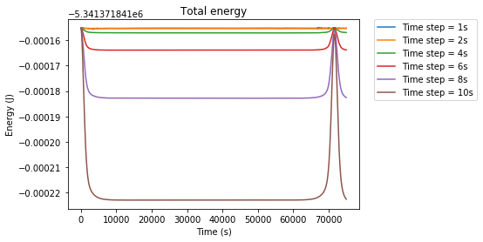Figure 2 shows that the change in kinetic energy of the rocket is opposite to the change in potential energy, this is shown in the resultant total energy appearing as a flat line. Figure 2 suggest then that energy is conserved, however on what scale is energy conserved and is it conserved for different sized time steps? To answer these questions a plot of total energy for different sized time steps was created.

Figure 3 Total energy of rocket for different time step sizes. Rocket had an initial starting position of (-12742,0) Km and an initial tangential velocity of 7191 m/s.

Figure 3 shows that as the size of the time step is reduced energy is better conserved. For larger time steps the total energy value seems to diverge quickly from an initial value. The region in which this divergence occurs is when there is the greatest change in kinetic and potential energy. The initial value seems to be the same for all the time steps and only the divergences seems to increase as the time step size increases. The total energy also seems to return to the initial values when a single orbit is complete and then diverge again. This suggests that there is a larger error in the kinetic energy calculations. The kinetic energy depends on v2 whereas the potential energy only depends on r. If r and v have the same size error after each iteration, then by squaring v you increase the error on the kinetic energy.

**Part B): Earth moon system**

The task for part b was to simulate the motion of a rocket moving through the potential well created by the earth and moon. Specifically, to simulate a flight path where the rocket would initially fire its thrusters from a low earth orbit (6.5km above the earth’s surface) fly past the moon and then fly back past earth. The goal is for the rocket to pass close enough to the moon to capture image of the lunar surface and then transmit the images back to earth via radio waves. If the position of the earth and moon are fixed where the earth centre of mass is at the point (0,0) and the moons centre of mass is at the point (0, 384,400) km the equation of motion of the rocket becomes

$$\begin{aligned}\ddot{r}=-\frac{MG}{{\left|r\right|}^{3}}r-\frac{M_{m}G}{|r-R_{m}|^{3}}\left(r-R_{m}\right) , \#\left(20\right)\end{aligned}$$

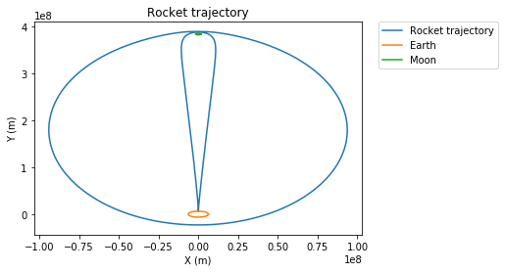Where Mm is the mass of the moon and Rm is the position of the moon. Using a similar method to part a, a function can be created to numerically solve equation 19. A nested loop was used to overlay multiple trajectories from an initial starting position of (0, 6.5) km above the earth’s surface and a range of velocities. By plotting multiple trajectories with different initial conditions at once, the initial conditions required for the rocket to go around the moon and then back passed the earth could be found through trial and error quicker then if individual simulations were run. Eventually a flight path with the required conditions was found.

Figure 4 flight path of a rocket with initial position of (0,6377.5) km and an initial velocity of (0.2,11.087) Km/s.

The rocket launches from its initial position, it is slingshotted by the moon once placing it in a large elliptical orbit around the earth it then is slingshotted by the moon a second time causing it to crash into the earth. The flight path can be seen clearer in the energy plot of figure 4

Figure 5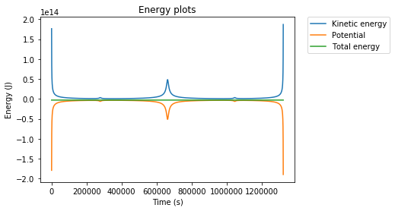 Energy plot of a rocket with initial position of (0,6377.5) km and an initial velocity of (0.2,11.087) Km/s.

There is an initial drop in the kinetic energy as the rocket moves away from the earth, then a peak at around 300,000s when the rocket passes the moon for the first time then there is a larger peak when the rocket approaches the earth during the elliptical orbit, then another spike when it goes past the moon for a second time and then finally a sharp increase in the kinetic energy before the rocket crashes into the earth. The total time taken was 1.32 $×10^{6}$ s and the closest approach to the moon was 2.75 $×10^{6}$ m. The total time taken for the simulation was 15.3 days. The moon has an orbital period of 27 days. Assuming the moon is stationary then during in our simulation is a bad approximation as the moon would have completed most it orbital path in this time. Even assuming the moon is stationary when the rocket goes past the moon for the first time (after approximately 3 days) is a bad approximation. The lower limit of angular resolution depends on the size of the lens aperture used. The relationship between lens size and angular resolution is

$$\begin{aligned}α=1.22\frac{λ}{D} , \#\left(21\right)\end{aligned}$$

Where $α$ is the angular resolution, D aperture size and λ is the wavelength of light being photographed. For a distance of 2.75 ×106 m to photograph the largest create on the moons surface (50 Km) across a camera with a lens aperture of 37µm or greater would have to be used. This is well within the realm of possibilities. So, if the right camera was chosen the moon surface could be photographed from this distance.

**Improvements**

The easiest improvement to make this model more realistic would be to include the gravitational effect each body has on another not just their cumulative effect on the rocket. This would especially increase the accuracy of part b where the total time of the simulation was 15.3 days a substantial chunk of the moons 27 days orbital period around the earth. A test of the accuracy of part a would be to compare our numerical solution of equation 9 to the analytical solution of a two-body system under the influence of gravity. Another test of accuracy could be to see if the results of our plot are in line with Kepler’s laws. An improvement on the method used to numerically solve the differential equations would be to use an adaptive time step. Adaptive time steps estimate the local error and change the timestep at that point to increase the accuracy of the solution.